# Biscuit information format

Include the name of your biscuit first and foremost. Describe what the biscuit is. Include ingredients and briefly how it is prepared/baked. Follow this with a fact about the chosen biscuit. This could be a piece of historical information, or basic trivia related to the biscuit. Also provide a simple image of the biscuit, of course.

So:

**NAME, DESCRIPTION, INGREDIENTS, HOW ITS MADE, FACT/TRIVIA.**

## Example:

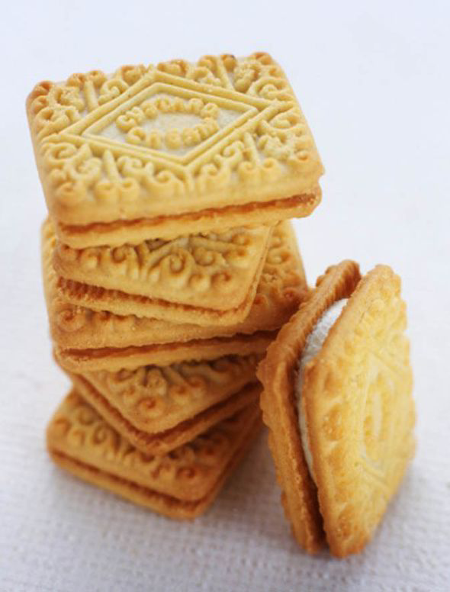

“Custard Creams! These are a type of ‘sandwich biscuit.’ They consist of a soft-set creamy filling, sandwiched between two soft buttery biscuits. The filling is traditionally a simple buttercream, but it can be flavoured however you wish. The ingredients of a basic custard cream consist of self-raising flour, butter, icing sugar, and custard powder. The biscuits are made by creaming the butter and icing sugar together, and then combining with the flour and custard power until the mixture forms into a paste. The paste is divided into small balls, or rectangles, and then baked. The buttercream filling is made simply by mixing the icing sugar together with the butter.

Custard creams are a British biscuit said to have originated back in 1908 in England. In modern day, they are ranked very highly! A poll in 2007 revealed that 9 out of 10 Britons considered them as their favourite biscuit. They are also excellent when dipped in tea.”

Even this example is still only 150ish words but is still adequate enough I would say.

(Note that the above image is just a placeholder for how it may appear on the website, not necessarily final image).